Learning Journey / Open Night – Wednesday, 30th August
Our annual learning journey will be held on Wednesday of next week between 5:00pm and 6:30pm. All classes will be open at the same time. This is a chance for your children to take you on a guided tour of their classroom, showing you their work and sharing their success with you.

Parents and family members are most welcome.

The oval will be open for extra parking. The approach is via Nolan Avenue. Turn right just before the railway line to take the gravel track up to the back gate.

Book Week Dress Up Day – August 31
Thanks to the enthusiasm of Mrs Condo and Miss Black, plus many parent requests, a dress up day to celebrate book week is being organised for Thursday of next week, August 31. Even though Book Week is this week, it is only fair to give you as much notice as possible.

This year’s theme is “Escape to Everywhere”. When you read, where does your mind like to escape to?

Dress up ideas can be found on the world wide web.
http://www.thebookchook.com/2017/04/ideas-for-childrens-book-week-2017.html

Placement Requests for 2018 Classes
Placement requests are due by Friday of next week, September 1. Teacher allocations to classes have not yet been made, so please don’t ask them what they will be teaching next year. Placement requests should not be about the teacher. Requests should be about the type of teacher you hope your child may have and be for educational reasons.

Whilst your requests are considered, the final decision is made by the principal in consultation with this year’s teachers. Once the lists are drawn up, we stand by them and children are usually not moved. Be assured that we have the best interests of your children at heart and that we will work to ensure that he or she is placed in a class that will meet their educational needs.

Requests may be emailed (Stephen.Green@education.wa.edu.au) or written. They are due by 3:00pm on Friday, September 1.

Are your children staying at Upper Swan Next Year?
Thank you to the families who have already contacted me about moving on next year.

When planning classes it is vital to have accurate student numbers. If you have children who are now in classes from Pre Primary to Year 5 and you know they won’t be returning next year please send me an email, a note or phone me. Making up classes is all about knowing exactly how many students we have in each year level. Your cooperation is greatly appreciated.

Woolworth’s Earn and Learn
Yes, we are registered for Woolworth’s Earn and Learn. Many families have already begun dropping in their reward stickers. We have a box at the local shops as well as in office reception. In previous years your support has enabled us to load up on a lot of bonus resources for English, Maths, sport, music and play equipment. Rally the troops and collect those tokens.

P & C Fathers’ Day Raffle
This is a reminder that our P & C is collecting donations for the Fathers’ Day raffle that will be held at the Fathers’ Day stall on Friday, September 1.

Assemblies – Term 3
Friday, August 25 Miss Reichenberg’s Year 4 class
Friday, September 8 Mr Probert and Mrs King’s Year 5/6 class
Friday, September 22 Talent Quest – managed by the Student Council
NAPLAN Reports for Year 3 and Year 5
From tomorrow, August 23, parents of Year 3 and Year 5 children are able to collect NAPLAN reports from their child’s teacher. The reports come with an information brochure that helps you understand the information on the report.

Class Photos – September 4 and 7
Class, family and group photos will be taken across these two days. Please make sure your children are wearing full school uniform on these days. That’s the red and blue polos, not faction shirts. School jumpers and rain jackets are fine along with school dresses, track pants, shorts, skorts and skirts.

Seth the MX Legend
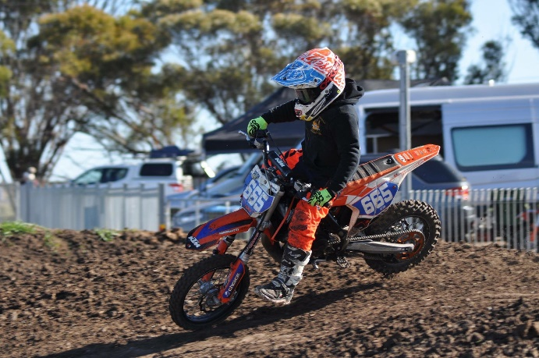
Seth is a year 3 student at our school. He began racing motocross at Chidlow in 2015 when he was 6 years old. 2016 was Seth’s first full year of competitive racing and amazingly he came away 3rd in the state in the 50cc class for 7-9 years and 5th in the 65cc 7-10yrs. Seth also competed in the Australian titles in Renmark, South Australia where he finished 11th out of 45 riders.

Seth has set his goals very high for 2017. His dedication to training to achieve these goals this year and beyond sees him training 3-4 times a week on and off his motocross bike, cycling 20kms twice a week and racing every weekend he can all around WA.

Seth travelled to Horsham Victoria in July to race and train in preparation for the Australian junior championship’s being held there in September. This is the biggest event of the year for Junior motocross and one which Seth aims to be up the front in both classes.

Seth currently leads the 2017 West Australian state title in the 50cc 7-9yrs and also in the 65cc 7-10yrs with 1 round remaining.

