Term Calendar Additions and Changes
At the end of last term a planner for Term 3 was emailed. Calendar dates are also noted on our website. From time to time updates occur. If you like to keep track of things, it will pay to make note of the updates.

- Class photos added to week 9: Tuesday 11th and Friday 14th September.
- Kindy and Pre Primary Tabloid Sports Fun day moved from August 31 to Thursday, September 6.
- Science Week / Science Day activities on Tuesday 14th or Wednesday 15th August. More information to follow.
- August 1st and 3rd: Pre Primary / Kindy Peel Zoo incursion

December Student Reports
Our plan is to use email to send out the final report for 2018 plus the position report for those who request one. If your email changes on the coming months, please let Mrs Lee or Mrs Reith (at office reception) know so your details can be updated.

Kindergarten and Pre Primary Enrolments for 2019
Enrolment applications were due last Friday, July 20. Whilst we still accept late applications, all families who had applications in on time are considered ahead of those who missed the July 20 deadline. If you lodged an application you will know the outcome within the next few weeks.

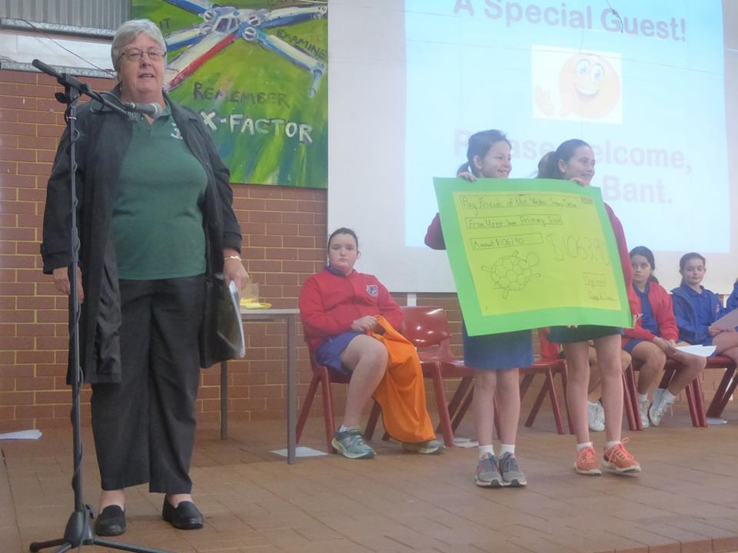
Friends of the Western Swamp Tortoise
Throughout terms 1 and 2 our Student Council coordinated several fundraising events to support this not for profit community group. They do important conservation work in our local area. In total we raised $1063.90. At last week’s assembly, Mrs Jan Bant gratefully accepted our cheque.

Interschool Cross Country – Friday, July 27
Best wishes to the team representing our school at Altone Park this coming Friday. The top 3 placegetters from our faction carnival (Year 3 to Year 6) have been invited to participate. Enjoy the experience.

Please be aware that Education Department policy has always been that public transport (buses) must be used for excursions. Only in circumstances where it is not practical for the school to organise a bus are we allowed to make alternative arrangements.

Next Assembly – Mrs Slater’s Year 4/5 Class, Friday August 10

Faction Athletics Practice
Weather permitting, faction athletics practice for all Year 1 to Year 6 students will take place after lunch on Fridays (1:50 to 2:50). Hopefully the uniform shop’s shirt order is not too far away. Students are encouraged to wear their team shirt on Fridays.

The main carnival date for Year 1 to Year 6 is Friday, September 7 with the Kindergarten and Pre Primary tabloid sports the day before, Thursday the 6th.

Busy Bee
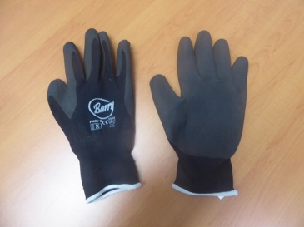
In last week’s P & C Grapevine you should have come across an update on the P & C Busy Bee held on June 30. I add my thanks and appreciation to P & C committee members, parent volunteers, students and staff who came along to lend a hand.

One of our volunteers left these gloves behind. They are a comfortable fit. If you would like them back, pop in to office reception.
Cyber Bullying
Although incidents of cyber bullying may not have been an issue for you and your children yet, you can be sure that exposure to the possibility of cyber bullying increases as children get older. Between the ages of 14 to 17, nearly all internet use for personal purposes is through social media such as Facebook, Instagram, Snapchat, Tumblr and YouTube. They are all avenues for cyber bullying.

In recent years at Upper Swan we have had isolated incidents of cyber bullying in the upper primary years, probably around once or twice per year that we are made aware of. The thing is, children are unlikely to tell parents or teachers about cyber bullying as they would rather keep their phone, iPad and computer.

This advice comes from an article published in the West Australian on June 20, 2018.

What can parents do?
- Don’t feel pressured to give your children access to technology and the internet too early. Children are quick learners and will work things out quickly.
- Talk to your children from a young age about their use of technology. Be interested and involved so these conversations become a normal part of family discussions. Get to know your children’s online friends and encourage your children to have online friends that they also know offline.
- Ask your children what apps and programs they are using online and go there yourself. Model best use to your children.
- Ask your children for help to use the apps and programs they use.
- If problems arise, stay calm and listen non-judgementally to what your child is saying and work together on a solution. Offer suggestions rather than taking away the technology. If you take away the technology your children will stop telling you about problems that come up.

Need Urgent Help?
- The school chaplain is available for students and families.
- Kids Helpline
- Office of eSafety
- Police
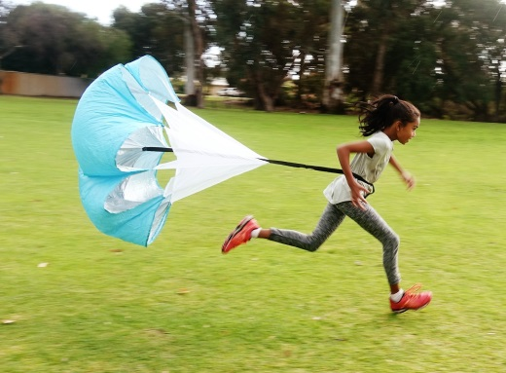
Sprints & Relays – After School Coaching at Upper Swan
Let’s Run Perth is offering the students of Upper Swan Primary School to join our Sprints & Relays program. Our coaches, winners of HBF Run & City to Surf, will teach your children better run technique and posture.

Suitable for Year 1-6. Fee is payable by bank transfers to Let’s Run Perth.

Every Fri, 3 Aug - 14 Sept: 7.45 - 8.30am School oval

Early bird registration fee: $84/child (if paid by 1 Aug)
Late registration fee: $94/child (if paid after 2 Aug)

Registration link: https://goo.gl/forms/fOXyVCGygMbhP1ei2
For more info, contact: Email: info@letsrunperth.com Text: 0402784225
Facebook: https://www.facebook.com/letsrunperth/

